Electronic Supplementary Material (ESI) for Catalysis Science & Technology.

This journal is © The Royal Society of Chemistry 2021

**Graphitic carbon nitride photocatalysis: the hydroperoxyl radical role**

**revealed by kinetic modelling**

Inmaculada Velo-Galaa*, André Torres-Pintoa, Cláudia G. Silvaa, Bunsho Ohtanib, Adrián M.T. Silvaa, Joaquim L. Fariaa

*aLaboratory of Separation and Reaction Engineering - Laboratory of Catalysis and Materials (LSRE-LCM), Faculdade de Engenharia, Universidade do Porto, Porto*

*4200-465, Portugal bInstitute for Catalysis, Hokkaido University, Sapporo 001-0021, Japan* *Corresponding author e-mail address: invega@fe.up.pt

# Supplementary Material

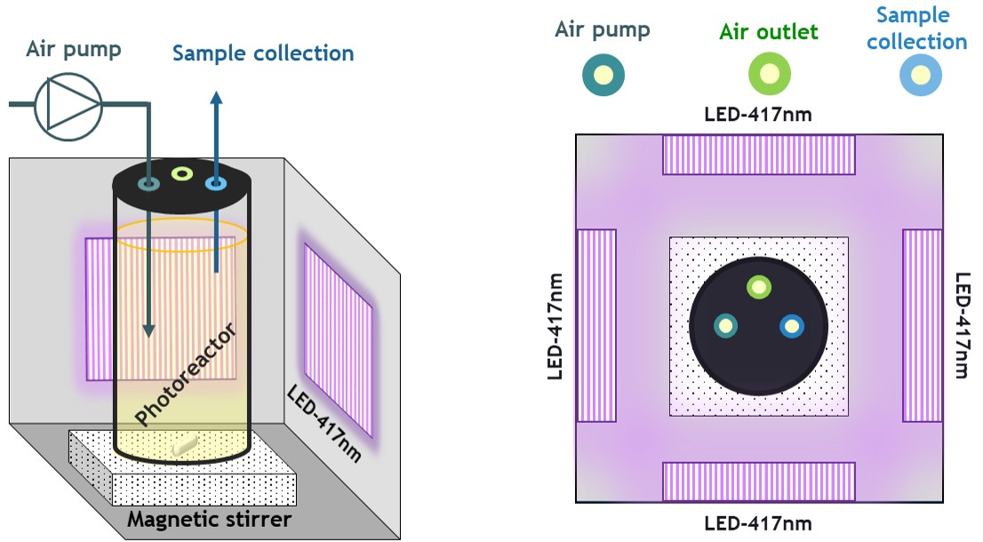

**Figure S1.** Schemeof the photocatalytic system with a three-dimensional view (left) and a top-viw cross-section (right).

**Table S1. Kintecus model reactions.**

Reactions and rate constants included in the kinetic model

|  |  |  |  |
| --- | --- | --- | --- |
| **Reaction no.** | **Reactions in LED-417/GCN** | **Rate constant *k*, (M**–**1****s**– **1)** | **Reference** |
| R1 | g-C3N4 + + *hν*  3e– + 3*h+* | 3.72 | This study |
| R2 | e– + *h+*  recombination | 1.001017 | This study |
| R3 | *h+* + H2O  HO + H+ | £ 1.00103 | This study |
| R4 | *h+* + H2O  ½O2 + H+ | 1.00103 | This study |
| R5 | *h+* + H2O2  O2 + 2H+ | 1.70-2.50109 | This study |
| R6 | *h+* + H2O2  HO2 + H+ | 2.00-3.00109 | This study |
| R7 | *h+* + C6H5OH  C6H5O + H+ | 1.00-2.001010 | This study |
| R8 | C6H5OH + HO  C6H5O + H2O | 6.00108 | [1] |
| R9 | C6H5OH + HO  C6H5(OH)2 | 1.351010 | [2] |
| R10 | C6H5OH + O2–  C6H5O– + HO2 | 5.80102 | [3] |
| R11 | C6H5OH + HO2 C6H5O– + H2O2 | 2.70103 | [4] |
| R12 | C6H5O + O2  C6H4O + HO2 | 1.30105 | [5] |
| R13 | C6H5O + O2–  C6H5O– + O2 | 2.00109 | [6] |
| R14 | C6H5O– + HO2  C6H5O + HO2– | 1.00109 | [7] |
| R15 | C6H5O– + O– + H+  C6H5O + HO– | 6.50108 | [8] |
| R16 | C6H5O– + HO  OHC6H5O– | 9.60109 | [9] |
| R17 | C6H5(OH)2 + e–  C6H5O + H2O | 1.00109 | [10] |
| R18 | C6H5(OH)2  C6H4(OH)2 + H+ | 8.00105 | [11] |
| R19 | C6H5(OH)2 + O2  C6H5(OH)2O2 | 1.20109 | [11] |
| R20 | C6H5(OH)2O2  C6H4(OH)2 + HO2 | 1.30105 | [11] |
| R21 | C6H4(OH)2 + O2–  H2O2 + C6H4O2 | 1.70107 | [12] |
| R22 | C6H4(OH)2 + HO2  H2O2 + C6H5O2 | 1.00103 | [13] |
| R23 | C6H4(OH)2 + HO  C6H4(OH)3 | 1.001010 | [14] |
| R24 | C6H4(OH)2 + O3  product | 1.50106 | [15] |
| R25 | C6H4O + HO  C6H5O + O– | 1.001010 | [14] |
| R26 | C6H4O2 + e–  C6H4O2– | 2.301010 | [16] |
| R27 | C6H4O2 + HO  C6H4O2(OH) | 1.20109 | [17] |

|  |  |  |  |
| --- | --- | --- | --- |
| R28 | C6H4O2 + O2–  O2 + C6H4O2– | 9.00108 | [18] |
| R29 | C6H5O2 + C6H5O2  C12H8(OH)2 + O2 | 1.10109 | [19] |
| R30 | e– + O2  O2– | 1.901010 | [16] |
| R31 | O2 + 2e– + 2H+  H2O2 | 1.901010 | [20] |
| R32 | O2– + H+  HO2 | 7.201010 | [21] |
| R33 | HO2  O2– + H+ | 1.6010–5 | [7] |
| R34 | HO2 + H+  H2O2 | 1.001010 | [7] |
| R35 | HO2 + O2–  O2 + HO2– | 9.70107 | [7] |
| R36 | H+ + HO–  H2O | 1.001011 | [22] |
| R37 | H2O  H+ + HO– | 1.3010–3 | [22] |
| R38 | HO2 + HO2  O2 + H2O2 | 3.40107 | [10] |
| R39 | HO2– + H+  H2O2 | 5.001010 | [22] |
| R40 | HO2– + O–  HO– + O2– | 4.00108 | [10] |
| R41 | H2O2  H+ + HO2– | 1.2610–1 | [22] |
| R42 | H2O2 + HO2  HO + O2 + H2O | 3.00 | [23] |
| R43 | H2O2 + 2e–  HO + HO– | 9.50109 | [16] |
| R44 | H2O2 + O2–  O2 + HO + HO– | 2.3010–1 | [24] |
| R45 | HO + H2O2  H2O + O2– + H+ | 2.70107 | [10] |
| R46 | HO + H2O2  HO2 + H2O | 2.70107 | [10] |
| R47 | HO + HO  H2O2 | 5.20109 | [10] |
| R48 | HO + HO–  H2O + O– | 1.301010 | [10] |
| R49 | HO + HO2  H2O + O2 | 7.53109 | [25] |
| R50 | HO + HO2–  H2O + O2– | 7.50109 | [10] |
| R51 | HO + O2–  O2 + HO– | 8.50109 | [25] |
| R52 | HO + O3–  HO2 + O2– | 8.50109 | [26] |
| R53 | HO + O–  HO2– | 2.001010 | [27] |
| R54 | H2O + O– + O2–  O2 + 2HO– | 6.00108 | [28] |
| R55 | H+ + O–  HO– | 2.201010 | [10] |
| R56 | O– + H2O  HO + HO– | 9.40107 | [10] |
| R57 | O– + O–  O2 + 2e– | 8.40109 | [29] |
| R58 | O– + O2  O3– | 3.60109 | [10] |
| R59 | O3– + O–  2 O2– | 7.00108 | [30] |
| R60 | O3– + H+  O2 + HO | 5.201010 | [31] |
| R61 | O3–  O2 + O– | 3.30103 | [32] |
| R62 | *h+* + HO–  HO | --- |  |

## **Text S1. 광촉매 속도의 이론적 계산**

g-C3N4 에 417 nm LED 조사에 의한 광촉매 반응상수(*kphoto*) 는 식 S1-S3로 계산했다.

*r*0

*k*photo= *I*0 (S1)

*r*0 = *k*obs ∙ *C*i (S2)

*C*i– *C*f

*k*obs = – ln (S3)

*C*i

여기에서 *r*0 는 광촉매 반응의 초기 속도상수(M s-1)이고 *I*0 는 입사 광 강도 (Einstein L-1·s-1), *k*obs 는 PhOH의 광분해 속도(실험?), *C*i 는 PhOH의 초기농도, *C*f 는 식 S4로 계산한 1초 후의 PhOH의 이론적 계산 농도이다. 반응시간을 1초로 한 이유는 페놀 분자가 흡수한 총 광자수를 초당 반응율로 하기 때문이다. [33].

absorbed photons at 1 seg (Einstein∙s-1) × *φ*

### *C*f = volume (L) (S4)

흡수된 광자는 반도체 입자의 흡수, 투과 및 산란으로 인한 광촉매 시스템으로 평가하기는 어렵다. 문헌[34-37]에 보고된 바에 의하면, 반응기 형상(조사 면적)과 몰 흡수율을 변형된 반응물 분자의 수를 반응기 내부에 입사하는 빛의 광자 수로 나누어 계산하였다. 평균 겉보기 양자 효율(j)은 반응기로 들어가는 광자에 대한 90% 변환된 반응물 분자의 비율로 했다(식 S5)[36, 38, 39].

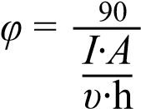*N*90 *t*

(S5)

*N*90 는 90%가 처리( transformed )된 시간(*t*90, 90 seconds)일때의 물질의 몰수이다.

*I* 는 광 조사 강도(Einstein m-2 s-1) 이다. *A* 는 촉매의 비표면적 (*S*BET, in m2 g-1) 과 촉매 질량(g)을 곱하여 추정한 촉매 활성 사이트(catalytically active sites)의 수이다. n 는 주파수(c/l), *h* 는 Planck constant 이다.

이 계산에서는 *S*BET 는 87 m2 g-1 로 가정하였다.[40].

BET 표면적은 흡착 부위의 수를 나타내지만 반드시 촉매 활성 부위의 수를 나타내는 것은 아니라는 점에 유의해야 한다. 그러나 이 가정은 광촉매 공정에서는 표면 특성에 따라 달라질 때 활성 부위에 대한 보수적인 추정으로 일반적으로 받아들여 질 수 있다.[39, 41]

## **Text S2. Sensitivity analysis**

The Normalised Residuals Sum of Squares (NRSS) value represents the average deviation of the resolved model from the experimental data. It is an indicator of the capacity of the model to reproduce the experimental data. The average RSS is defined as

Equation S.6:

*n*

1 |*Mi* – *Di*|

NRSS = % (S6) *n Di i*=1

Where *Mi* is the model response at a given system condition and time, *Di* is the experimental data at the same given condition and time, and *n* is the total number of measured data points over all conditions and time. To analyse the effect of changes on specific rate constant values [42], the NRSS was calculated by running the model while varying one rate constant with all others held fixed at their optimised values. In this case, the *Di* is the altered model response at the same condition and time as the control model.

### A) e– + *h+*  recombination

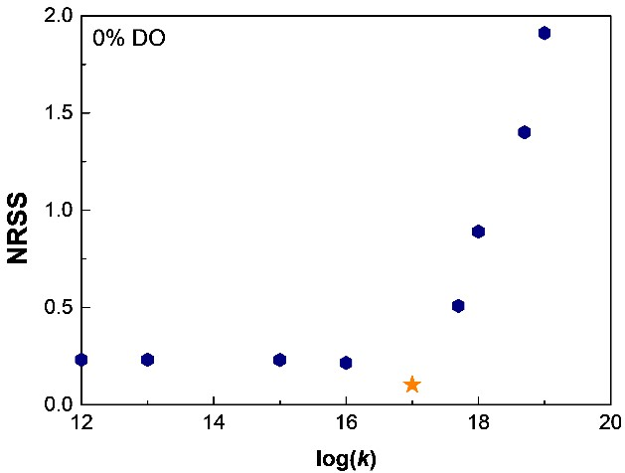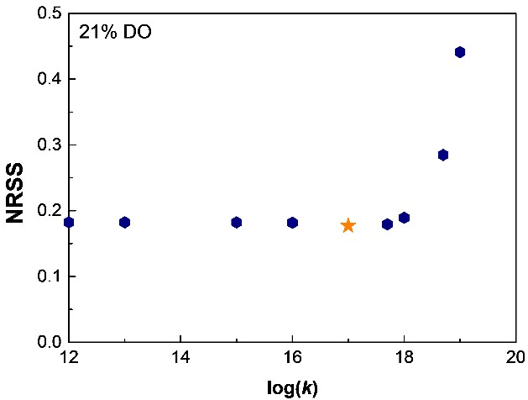

## B) *h+* + H2O  HO + H+

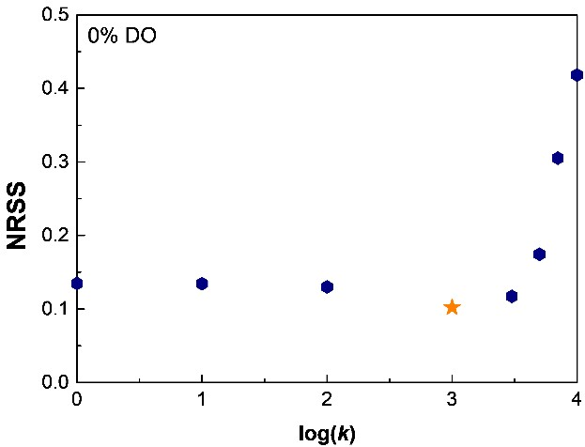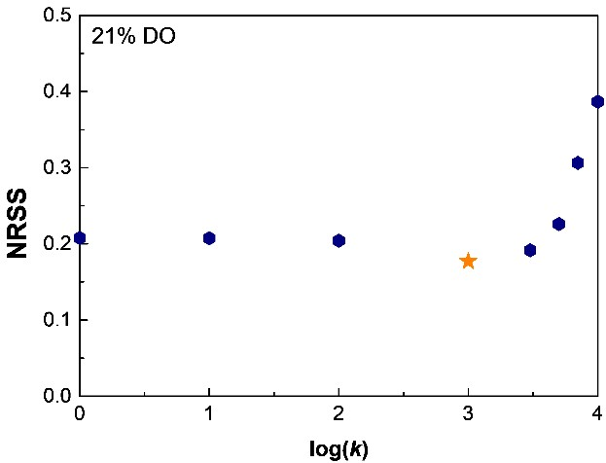

## C) *h+* + H2O  ½O2 + H+

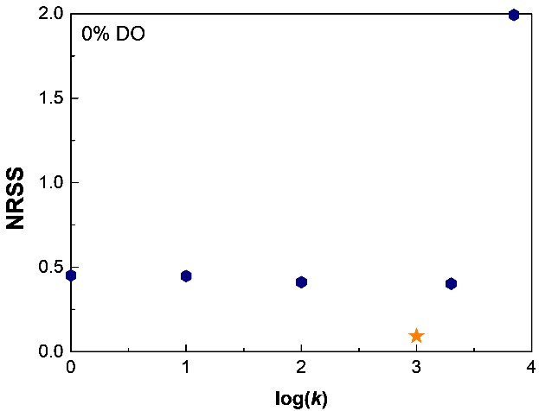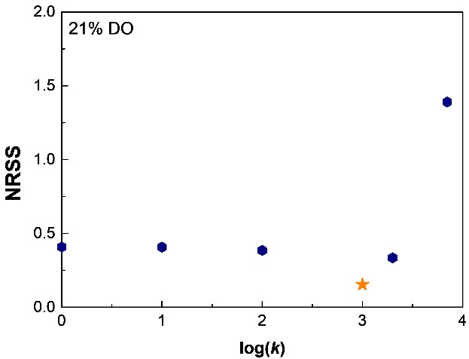

## D) *h+* + HO–  HO

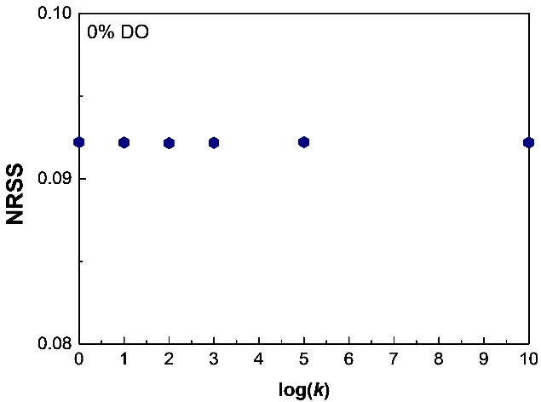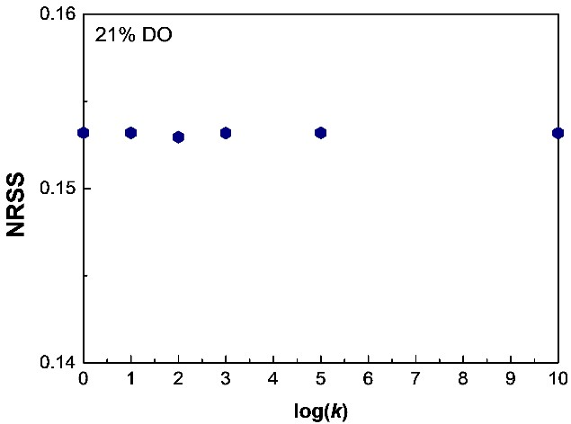

## E) *h+* + H2O2  O2 + 2H+

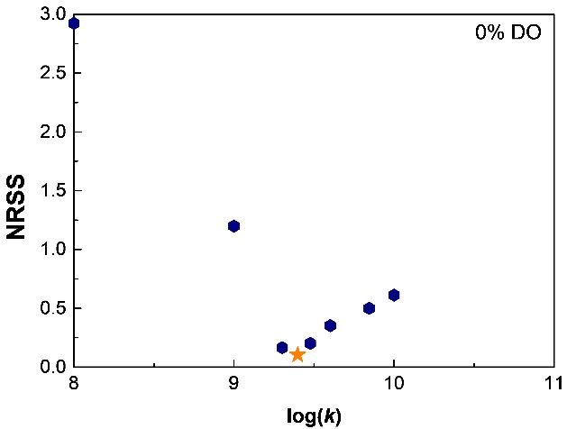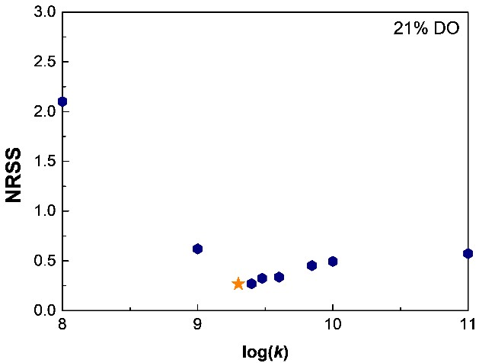

## F) *h+* + H2O2  HO2 + H+

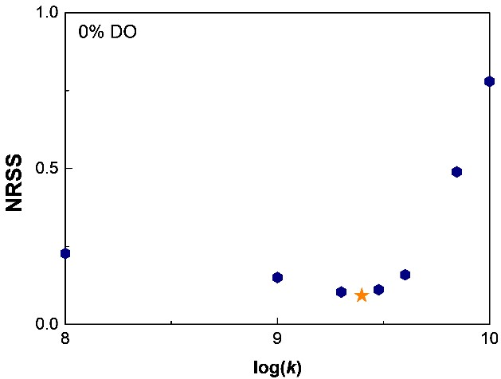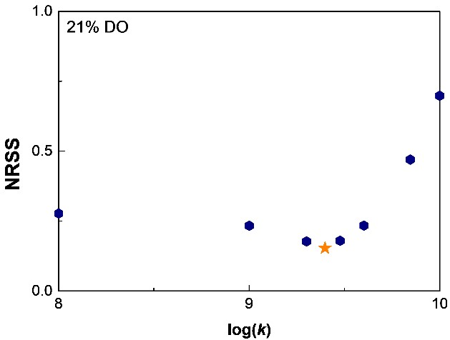

**Figure S2.** Sensitivity analysis of fitting reaction rate constants: kinetic model of H2O2 removal by the LED-417/GCN system. Initial conditions: pH0=6.1; [H2O2]0=110-3 M.

### A) e– + *h+*  recombination

12

14

16

18

20

0.00

0.05

0.10

0.15

0.20

0.0770

0.0775

0.0780

0.0785

0.0790

0.0795

0.0800

**PhOH**

**2**

**H**

**2**

**O**

**2**

**log**

**(**

***k***

**)**

**NRSS**

**NRSS**

## B) *h+* + H2O  HO + H+

0

1

2

3

4

5

0.00

0.05

0.10

0.15

0.20

0.00

0.05

0.10

0.15

0.20

0.25

0.30

0.35

**log**

**(**

***k***

**)**

**NRSS**

**PhOH**

**2**

**H**

**2**

**O**

**2**

**NRSS**

## C) *h+* + H2O  ½O2 + H+

0

1

2

3

4

5

0.00

0.05

0.10

0.15

0.20

0.25

0.30

0.35

0.00

0.05

0.10

0.15

0.20

0.25

**log**

**(**

***k***

**)**

**NRSS**

**PhOH**

**2**

**H**

**2**

**O**

**2**

**NRSS**

## D) *h+* + HO–  HO

0

1

2

3

4

5

0.070

0.072

0.074

0.076

0.078

0.080

0.082

0.084

0.086

0.0770

0.0772

0.0774

0.0776

0.0778

0.0780

**log**

**(**

***k***

**)**

**NRSS**

**PhOH**

**2**

**H**

**2**

**O**

**2**

**NRSS**

1. *h+* + H2O2  O2 + 2H+

7

8

9

10

11

0.0

0.5

1.0

1.5

0.0

0.1

0.2

0.3

0.4

0.5

**PhOH**

**2**

**H**

**2**

**O**

**2**

**NRSS**

**NRSS**

**log(*k*)**

1. *h+* + H2O2  HO2 + H+

6

7

8

9

10

11

0.0

0.5

1.0

1.5

0.00

0.05

0.10

0.15

0.20

0.25

**PhOH**

**2**

**H**

**2**

**O**

**2**

**NRSS**

**NRSS**

**log(*k*)**

1. *h+* + C6H5OH  C6H5O + H+

**log(*k*)**

**Figure S3.** Sensitivity analysis of fitting reaction rate constants: kinetic model of PhOH removal and H2O2 generation by the LED-417/GCN system. Initial conditions: pH0=6.1;

[PhOH]0= 6.3810–4 M.

**Table S2.** Photocatalytic results of PhOH degradation and H2O2 generation in the LED-417/GCN system. Experimental initial conditions: pH0 = 6.1; [PhOH]0 =

6.3810-4 M.

7

8

9

10

11

12

0.0

0.5

1.0

1.5

2.0

2.5

3.0

3.5

0.00

0.05

0.10

0.15

0.20

0.25

0.30

0.35

0.40

**PhOH**

**2**

**H**

**2**

**O**

**2**

**NRSS**

**NRSS**

|  |  |  |  |  |  |  |
| --- | --- | --- | --- | --- | --- | --- |
| **O2** **(%)** | **PhOH**  **removal**  ***k*app** **102**  **(min-1)** | **% PhOH removal**  **(60 min)** | **H2O2**  **formation rate** ***k*app** **105**  **(min-1)** | **[H2O2]/ mmol L-1**  **(60 min)** | **Max.**  **[H2O2]/ mmol L-1**  **(time/min)** | **pH value**  **(180 min)** |
| **0** | 0.05 | 6.85 | 0 | 0 | 0 | 8.41 |
| **5** | 0.62 | 26.5 | 0.40 | 0.29 | 0.66 (180) | 7.02 |
| **10** | 1.98 | 65.0 | 0.85 | 0.51 | 0.74 (150) | 5.13 |
| **21** | 2.73 | 85.6 | 1.53 | 0.88 | 0.90(120) | 4.06 |
| **100** | 6.14 | 100 | 2.91 | 0.96 | 0.96 (60) | 3.83 |

**Table S3.** Percentages of PhOH removal depending on the reactive species and the percentage of dissolved oxygen. Data obtained from Kintecus modelling.

|  |  |  |  |  |  |  |  |
| --- | --- | --- | --- | --- | --- | --- | --- |
| **%DO** | **Final degradation**  **(%)** | **Degradation rate constant *k*app** **102 (min-1)** | **%D(*h+*) R7** | **%D(HO****) R8** | **%D(HO****) R9** | **%D(O2****–) R10** | **%D(HO2****) R11** |
| 0 | 8.46 | 0.05 | 7.98 | 0.00 | 0.03 | 0.00 | 0.45 |
| 5 | 71.9 | 0.60 | 67.2 | 0.01 | 0.21 | 0.00 | 4.47 |
| 10 | 100 | 1.80 | 72.5 | 0.01 | 0.27 | 0.02 | 27.7 |
| 21 | 100 | 2.56 | 62.3 | 0.01 | 0.15 | 0.05 | 37.5 |
| 100 | 100 | 5.95 | 62.2 | 0.01 | 0.14 | 0.05 | 37.6 |

**Table S4.** Percentages of H2O2 formation depending on the reaction pathway and the amount (%) of dissolved oxygen (DO). Data obtained from Kintecus modelling.

|  |  |  |  |  |  |  |  |
| --- | --- | --- | --- | --- | --- | --- | --- |
| **DO**  **(%)** | **Max. [H2O2]/ mmol L-1**  **(time/min)** | **H2O2 formation rate *k*app** **105**  **(min-1)** | **%R11** | **%R21** | **%R22** | **%R38** | **%R39** |
| 0 | 0.04 (180) | 0.02 | 67.0 | 0.00 | 0.00 | 0.50 | 32.5 |
| 5 | 0.67 (180) | 0.38 | 63.6 | 0.22 | 0.08 | 5.60 | 30.5 |
| 10 | 0.74 (114) | 0.83 | 35.7 | 0.25 | 0.04 | 50.6 | 13.4 |
| 21 | 0.97 (88) | 2.11 | 29.4 | 0.20 | 0.00 | 70.4 | 0.00 |
| 100 | 0.96 (73) | 2.39 | 27.7 | 0.20 | 0.00 | 72.1 | 0.00 |

The rest of the reactions (R35, R47, R31) that could form H2O2 had no contribution to the model.

**Table S5.** Percentages of H2O2 removal depending on the reaction and the amount (%) of dissolved oxygen (DO). Data obtained from Kintecus modelling.

|  |  |  |  |  |  |  |
| --- | --- | --- | --- | --- | --- | --- |
| **DO**  **(%)** | **Degradation (%)** | **Degradation rate constant *k*** **106 (min-1)** | **% R5** | **% R6** | **% R42** | **% R46** |
| 0 | 1.27 | 0 | 0.55 | 0.66 | 0.00 | 0.00 |
| 5 | 15.9 | 0 | 7.22 | 8.66 | 0.00 | 0.00 |
| 10 | 100 | 2.45 | 45.3 | 54.3 | 0.10 | 0.30 |
| 21 | 100 | 2.64 | 45.4 | 54.5 | 0.10 | 0.00 |
| 100 | 100 | 2.63 | 45.4 | 54.5 | 0.10 | 0.00 |

The rest of the reactions (R43, R45) that could remove H2O2 had no contribution to the model.

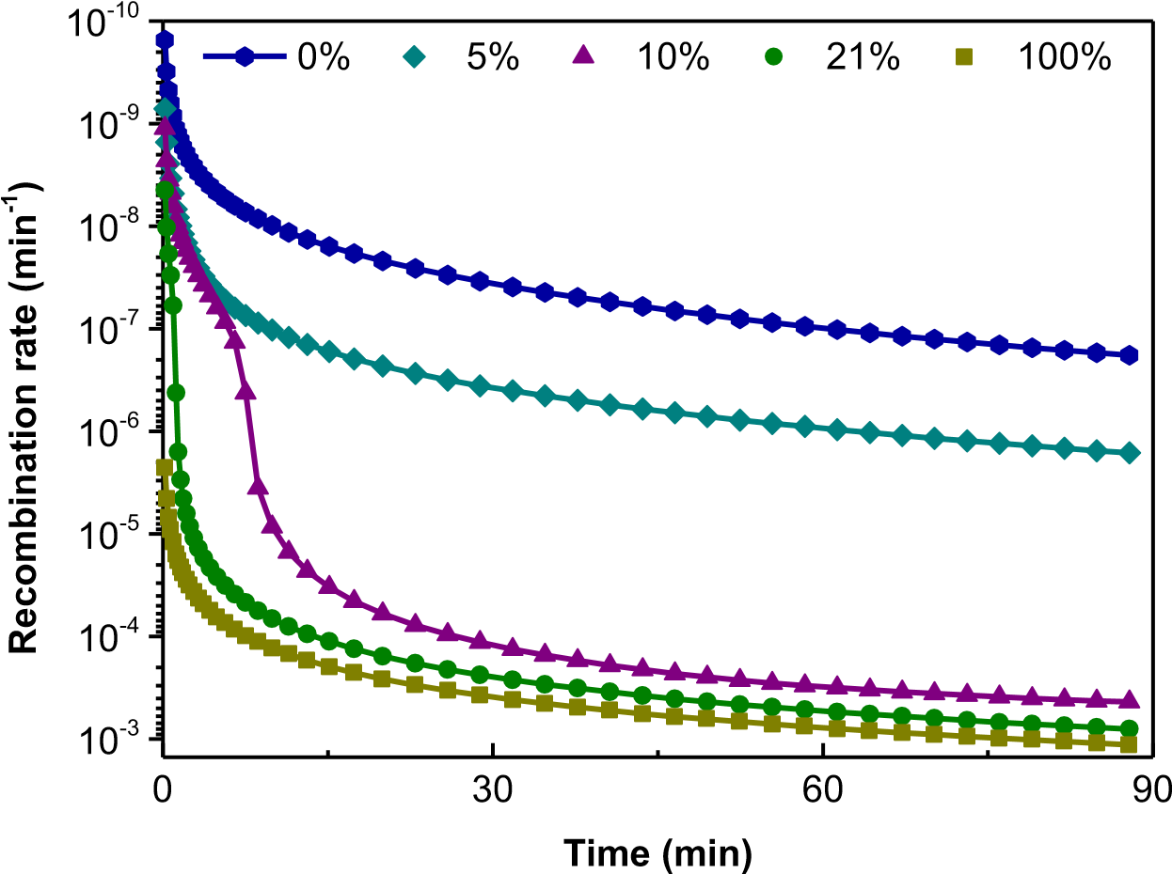

**Figure S4.** Kinetic model of the recombination *e–*/*h+* reaction in the LED-417/GCN system for different percentages of dissolved oxygen (DO).

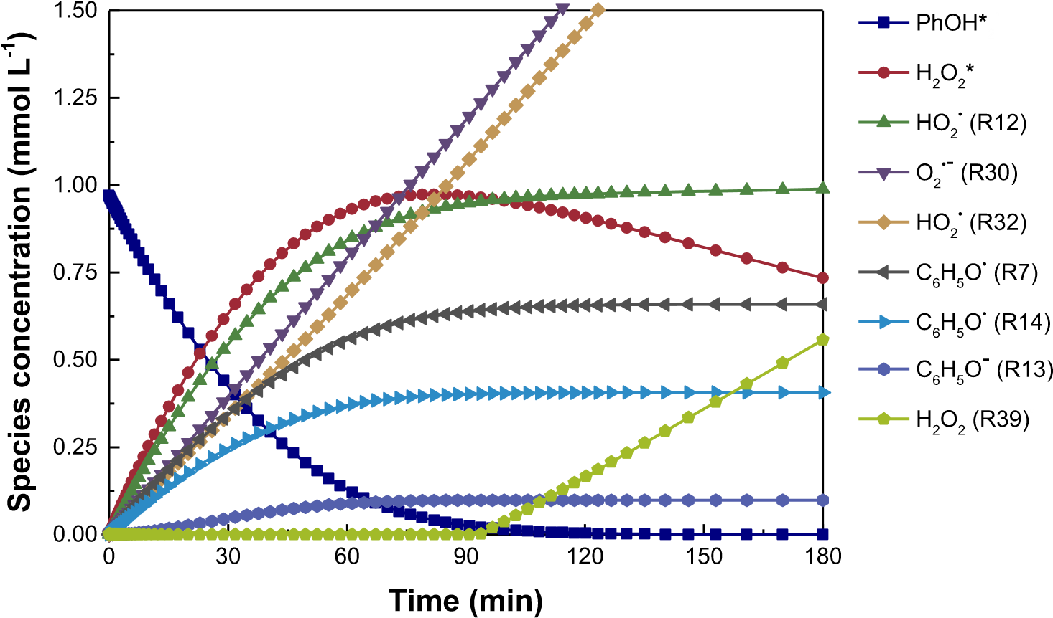

**Figure S5.** Kinetic modelling for the most relevant reactions involved in H2O2 generation.

DO 21%. Initial conditions: pH0=6.1; [PhOH]0= 6.3810–4 M. LED-417/GCN system.

### **Supplementary characterisation of GCN**

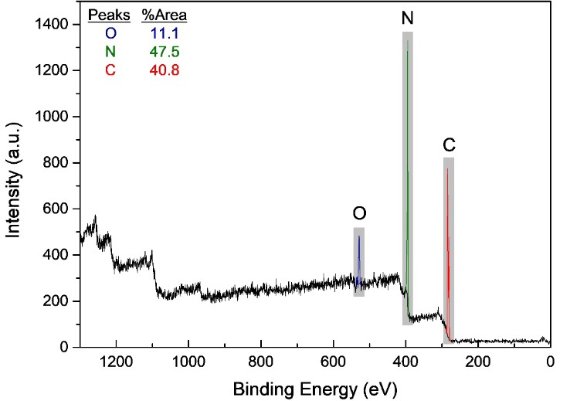

**Figure S6.** XPS survey spectra of GCN.

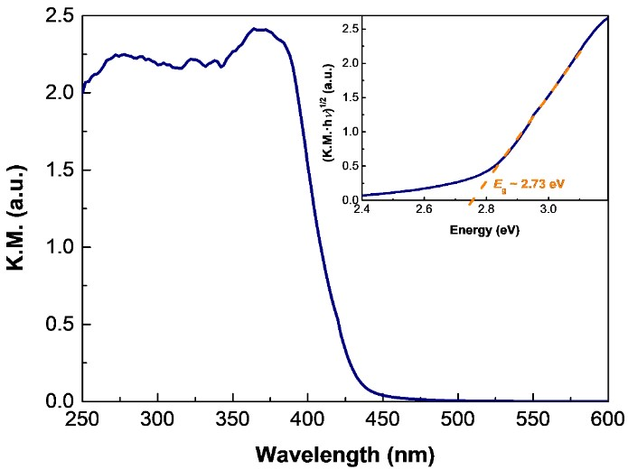

**Figure S7.** DRS and Tauc plot (inset) of GCN.

### **Bibliography**

1. L.M. Dorfman, G.E. Adams, Reactivity of the Hydroxyl Radical in Aqueous

Solutions, National Bureau of Standards, U. S. Department of Commerce1973.

1. E.J. Land, M. Ebert, *Trans. Faraday Soc.*, 1967, **63**, 1181-1190.
2. T. Yasuhisa, H. Hideki, Y. Muneyoshi, *Int. J. Biochem.*, 1993, **25**, 491-494.
3. Z. Kozmér, E. Arany, T. Alapi, E. Takács, L. Wojnárovits, A. Dombi, *Radiat. Phys. Chem.*, 2014, **102**, 135-138.
4. E. Mvula, M.N. Schuchmann, C. von Sonntag, *J. Chem. Soc., Perkin Trans. 2*, 2001, 264-268.
5. M. Jonsson, J. Lind, T. Reitberger, T.E. Eriksen, G. Merenyi, *J. Phys. Chem.*, 1993, **97**, 8229-8233.
6. B.H.J. Bielski, D.E. Cabelli, R.L. Arudi, A.B. Ross, *J. Phys. Chem. Ref. Data*, 1985,

**14**, 1041-1100.

1. P. Neta, R.H. Schuler, *Radiat. Res.*, 1975, **64**, 233-236.
2. R.W. Matthews, D.F. Sangster, *J. Phys. Chem.*, 1965, **69**, 1938-1946.
3. G.V. Buxton, C.L. Greenstock, W.P. Helman, A.B. Ross, *J. Phys. Chem. Ref. Data*, 1988, **17**, 513-886.
4. X.-M. Pan, M.N. Schuchmann, C. von Sonntag, *J. Chem. Soc., Perkin Trans. 2*,

1993, 1021-1028.

1. P.S. Rao, E. Hayon, *J. Phys. Chem.*, 1975, **79**, 397-402.
2. A.D. Nadezhdin, H.B. Dunford, *Can. J. Chem.*, 1979, **57**, 3017-3022.
3. G.E.B. Adams, J.W.; Currant, J.; Michael, B.D., Pulse Radiolysis - Absolute rate constants for the reaction of the hydroxyl radical with organic compounds, Academic

Press, New York1965.

1. M.D. Gurol, S. Nekouinaini, *Ind. Eng. Chem. Fundam.*, 1984, **23**, 54-60.
2. B.H. Milosavljevic, O.I. Micic, *J. Phys. Chem.*, 1978, **82**, 1359-1362.
3. G.E. Adams, B.D. Michael, *Trans. Faraday Soc.*, 1967, **63**, 1171-1180.
4. C.L. Greenstock, G.W. Ruddock, *Int. J. Radiat. Phys. Chem.*, 1976, **8**, 367-369.
5. X. Fang, R. Mertens, C. von Sonntag, *J. Chem. Soc., Perkin Trans. 2*, 1995, 10331036.
6. E. Bjergbakke, Ζ.D. Dragarne, Κ. Sehested, I.G. Dragarne, *Radiochim. Acta*, 1989,

**48**, 65-72.

1. R.J. Field, R.M. Noyes, D. Postlethwaite, *J. Phys. Chem.*, 1976, **80**, 223-229. [22] Y. Yang, J.J. Pignatello, J. Ma, W.A. Mitch, *Environ. Sci. Technol.*, 2014, **48**, 23442351.
2. W.H. Koppenol, J. Butler, J.W.v. Leeuwen, *Photochem. Photobiol.*, 1978, **28**, 655658.
3. C. Ferradini, J. Foos, C. Houee, J. Pucheault, *Photochem. Photobiol.*, 1978, **28**, 697-

700.

1. A.J. Elliot, G.V. Buxton, *J. Chem. Soc. Faraday Trans.*, 1992, **88**, 2465-2470. [26] K. Sehested, J. Holcman, E. Bjergbakke, E.J. Hart, *J. Phys. Chem.*, 1984, **88**, 269-

273.

1. J. Rabani, M.S. Matheson, *J. Phys. Chem.*, 1966, **70**, 761-769.
2. K. Sehested, J. Holcman, E. Bjergbakke, E.J. Hart, *J. Phys. Chem.*, 1982, **86**, 20662069.
3. G.E. Adams, J.W. Boag, B.D. Michael, L.H. Gray, *Proc. R. Soc. A*, 1966, **289**, 321-

341.

1. B.L. Gall, L.M. Dorfman, *J. Am. Chem. Soc.*, 1969, **91**, 2199-2204.
2. R.E. Buehler, J. Staehelin, J. Hoigne, *J. Phys. Chem.*, 1984, **88**, 2560-2564.
3. D. Behar, G. Czapski, *Isr. J. Chem.*, 1968, **6**, 43-51.
4. A.E. Cassano, C.A. Martin, R.J. Brandi, O.M. Alfano, *Ind. Eng. Chem. Res.*, 1995,

**34**, 2155-2201.

1. M.I. Cabrera, O.M. Alfano, A.E. Cassano, *J. Phys. Chem.*, 1996, **100**, 20043-20050. [35] O. Carp, C.L. Huisman, A. Reller, *Prog. Solid. State Ch.*, 2004, **32**, 33-177. [36] V. Loddo, M. Addamo, V. Augugliaro, L. Palmisano, M. Schiavello, E. Garrone,

*AIChE J.*, 2006, **52**, 2565-2574.

1. N. Serpone, *J. Photochem. Photobiol. A*, 1997, **104**, 1-12.
2. N.J. Peill, M.R. Hoffmann, *Environ. Sci. Technol.*, 1995, **29**, 2974-2981. [39] N. Serpone, A. Salinaro, A. Emeline, V. Ryabchuk, *J. Photochem. Photobiol. A*, 2000, **130**, 83-94.
3. A. Torres-Pinto, M.J. Sampaio, C.G. Silva, J.L. Faria, A.M.T. Silva, *Appl. Catal. BEnviron.*, 2019, **252**, 128-137.
4. B.S. Hugo de Lasa, Miguel Salaices, Photocatalytic Reaction Engineering - Chapter

6: The Energy Efficiency Factors in Photocatalytic Processes, 1 ed., Springer US2005.

1. A.L. Rose, T.D. Waite, *Environ. Sci. Technol.*, 2002, **36**, 433-444.